September 2, 2026

VIA EDGAR

U.S. Securities and Exchange Commission
100 F Street, N.E.
Washington, D.C. 20549

Re: | Neostellar Capital Corp. (f/k/a SuRo Capital Corp.)
 | File No. 814-00852
 | Rule 17g-1 Fidelity Bond Filing

Ladies and Gentlemen:

On behalf of Neostellar Capital Corp. (the “Company”), enclosed herewith for filing, pursuant to Rule 17g-1(g) under the Investment Company Act of 1940, as amended (the “1940 Act”), are the following:

 | 1. | a copy of the fidelity bond covering the Company in the amount of $1,000,000 (the “Bond”); and
 | 2. | a Certificate of the Secretary of the Company containing a statement as to the period for which premiums have been paid and the resolutions approved on July 30, 2026 by the board of directors of the Company, pursuant to which a majority of the directors who are not “interested persons” of the Company, as defined under Section 2(a)(19) of the 1940 Act, approved the amount, type, form and coverage of the Bond.

If you have any questions regarding this submission, please do not hesitate to call me at (212) 931-6331.

Sincerely,
NEOSTELLAR CAPITAL CORP.
/s/ Allison Green
Allison Green
Chief Financial Officer, Treasurer and Corporate Secretary of the Company

Enclosures

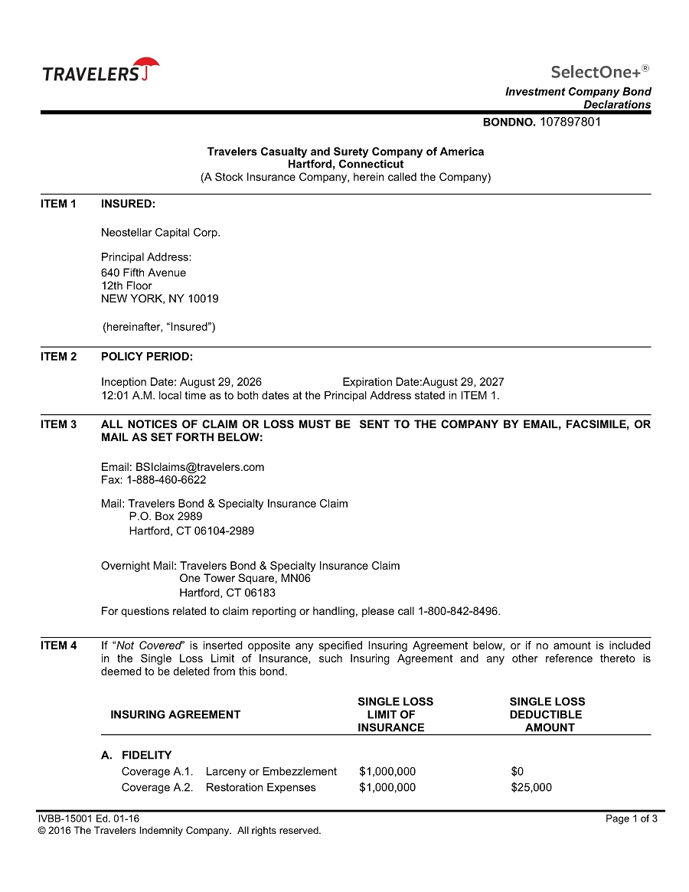

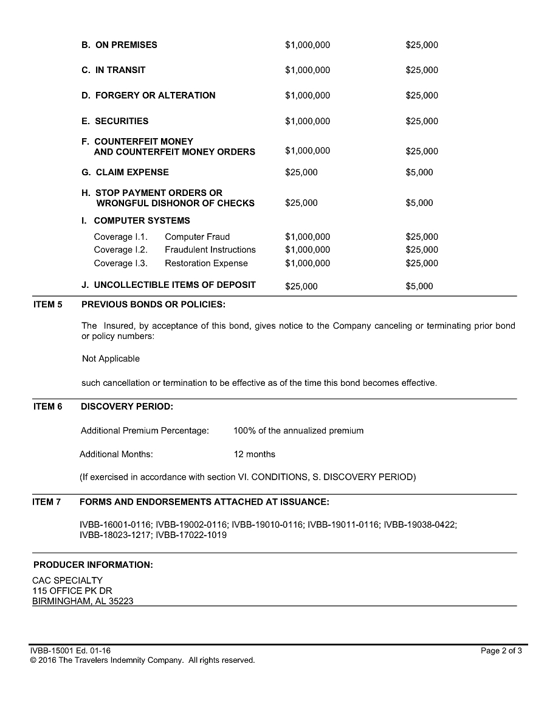

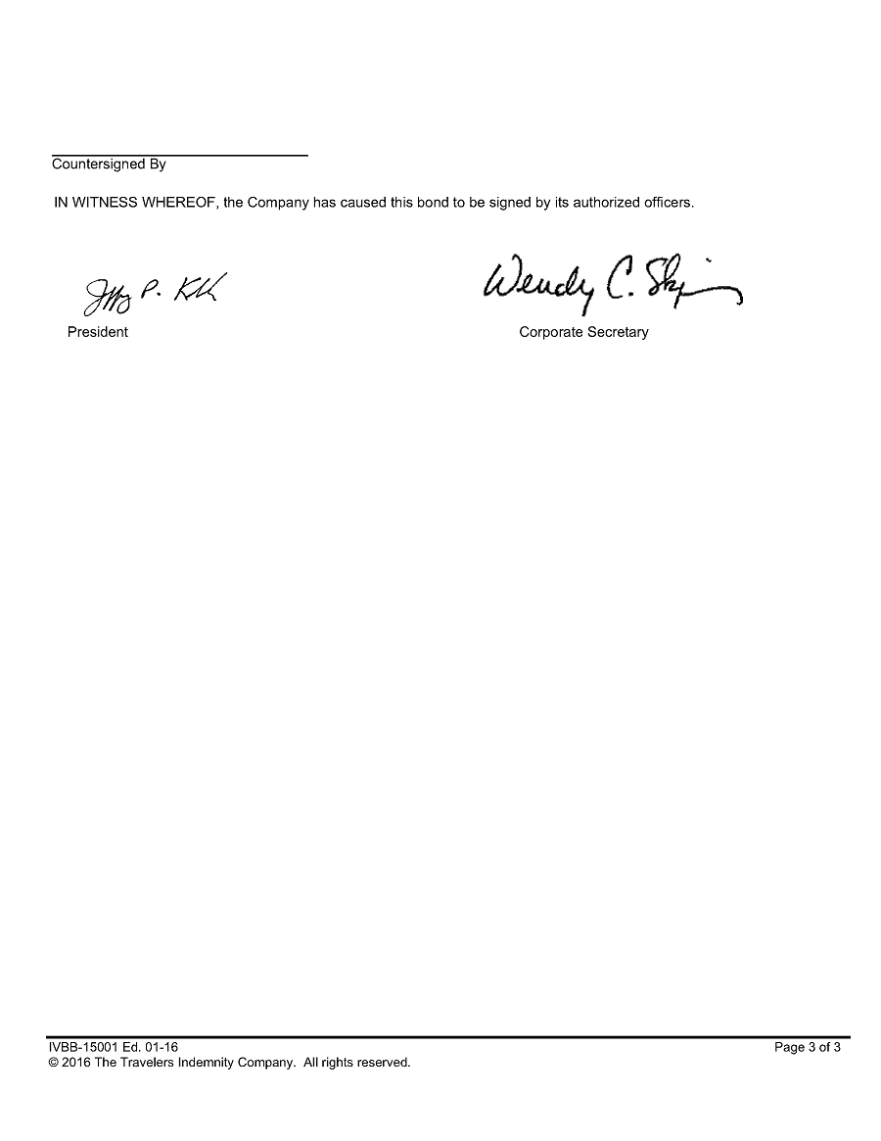

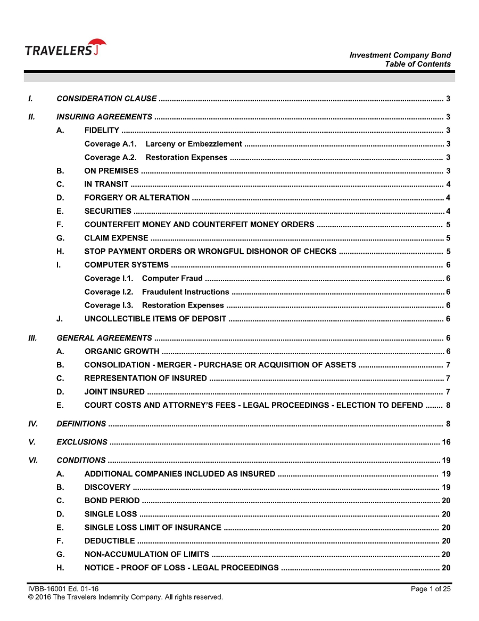

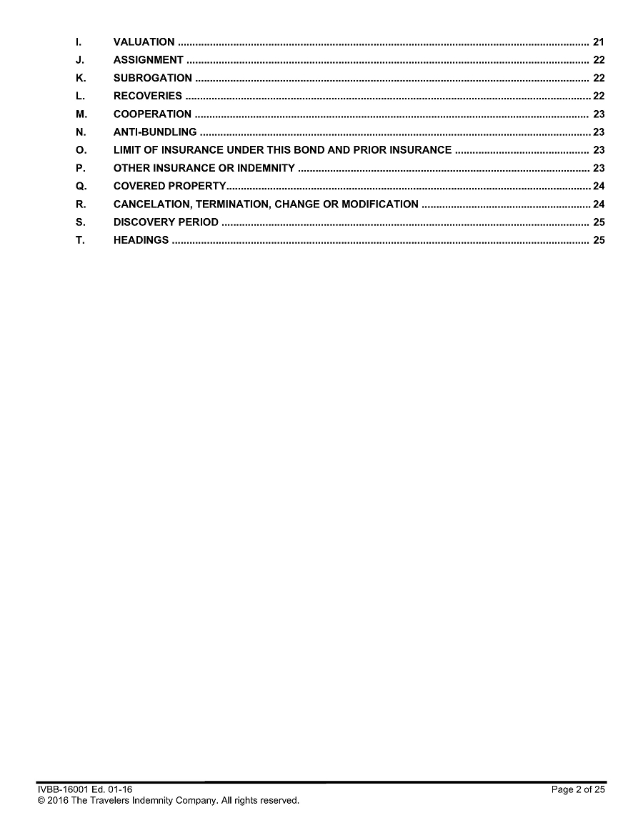

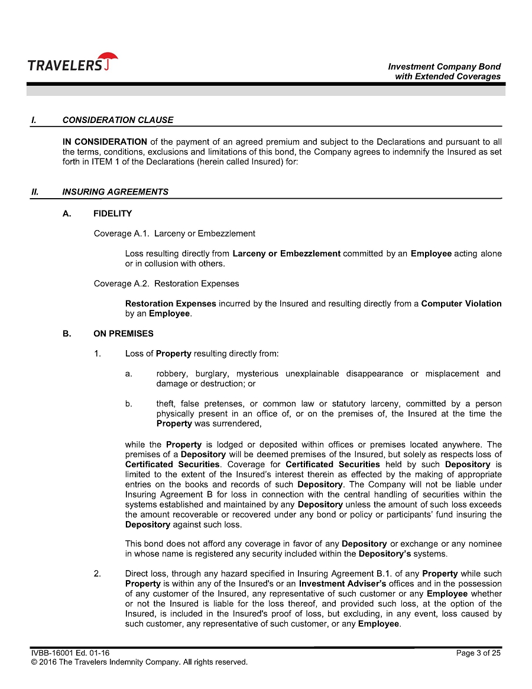

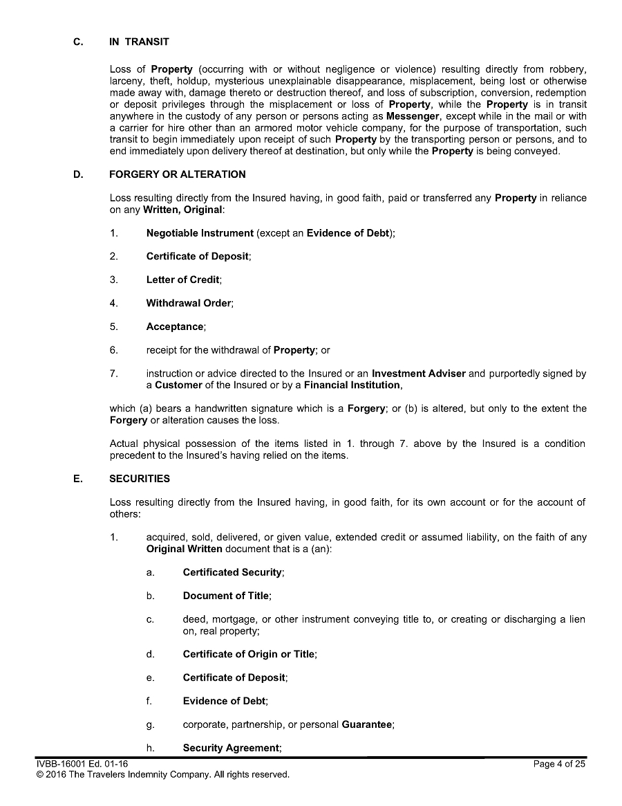

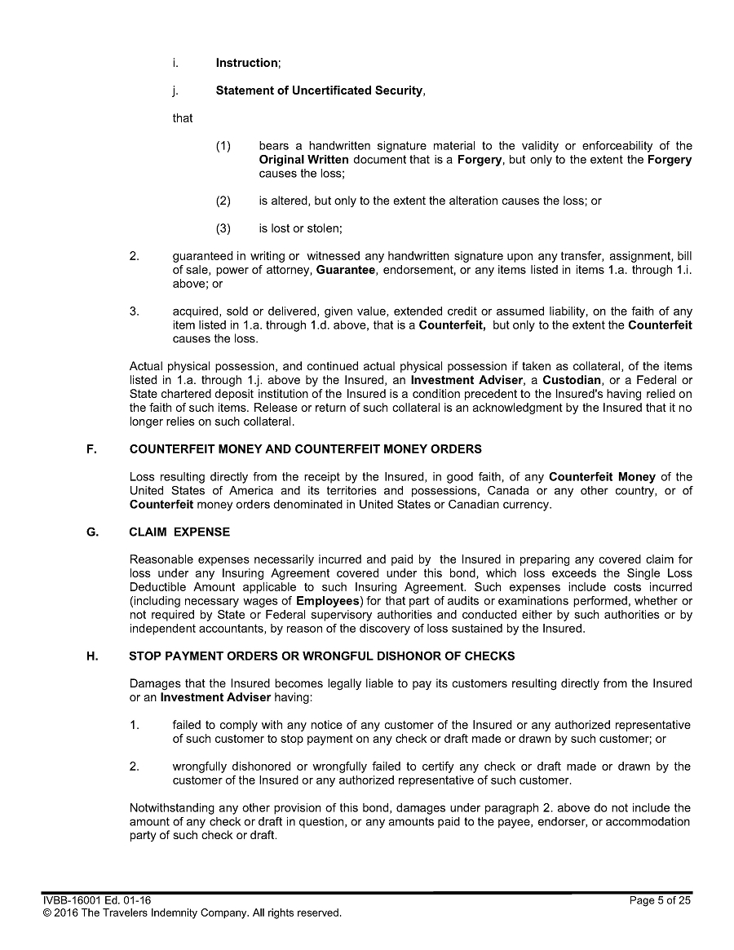

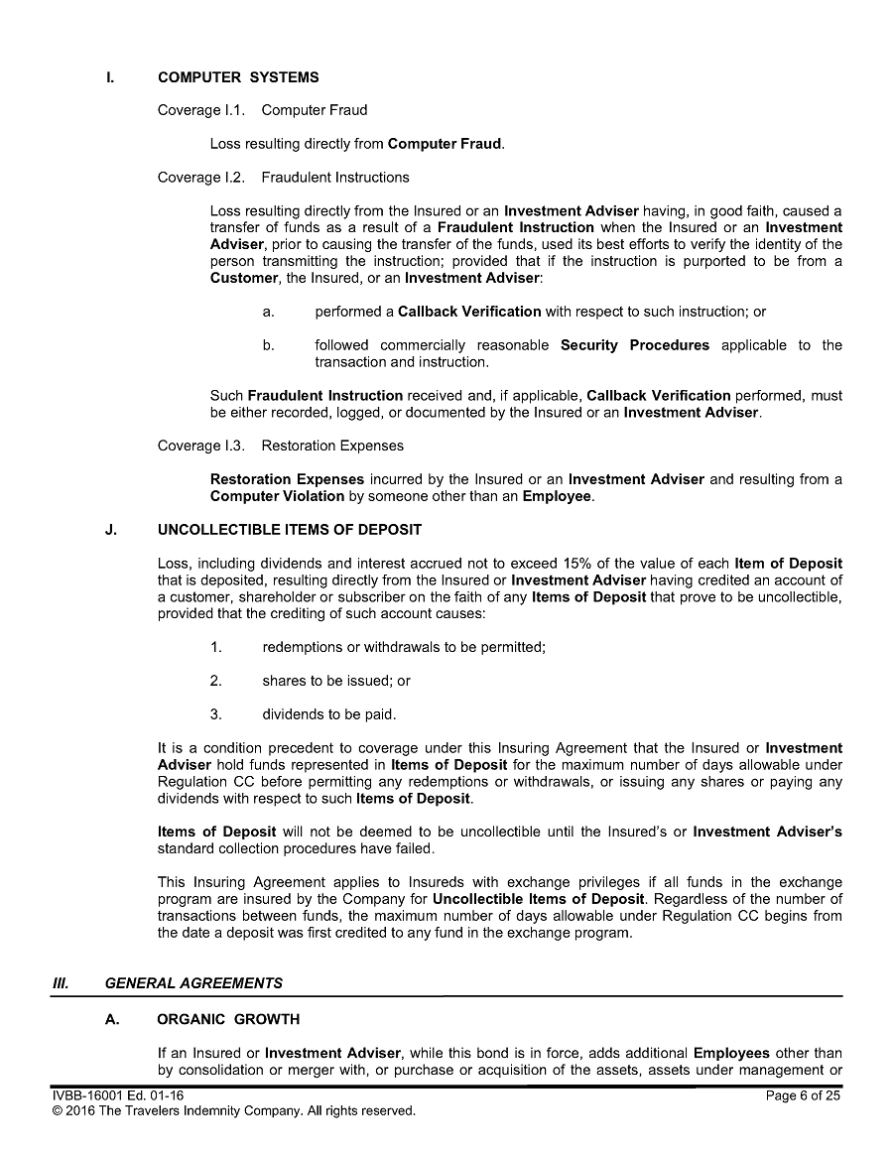

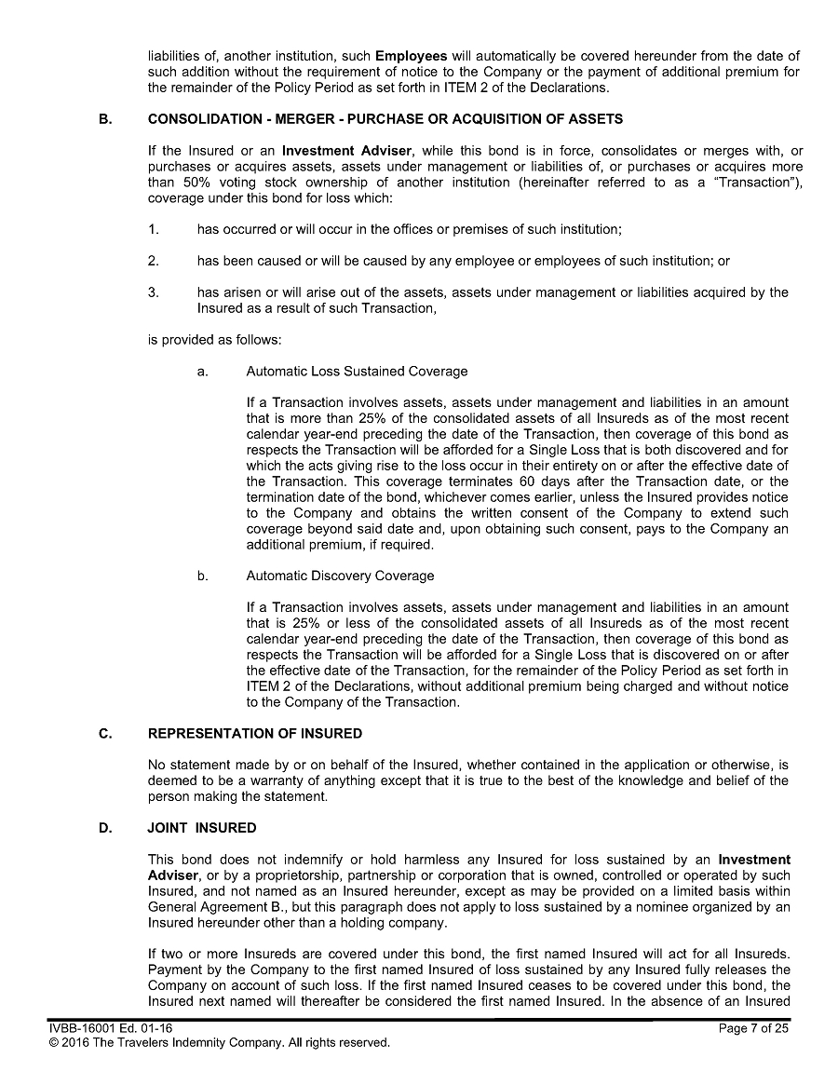

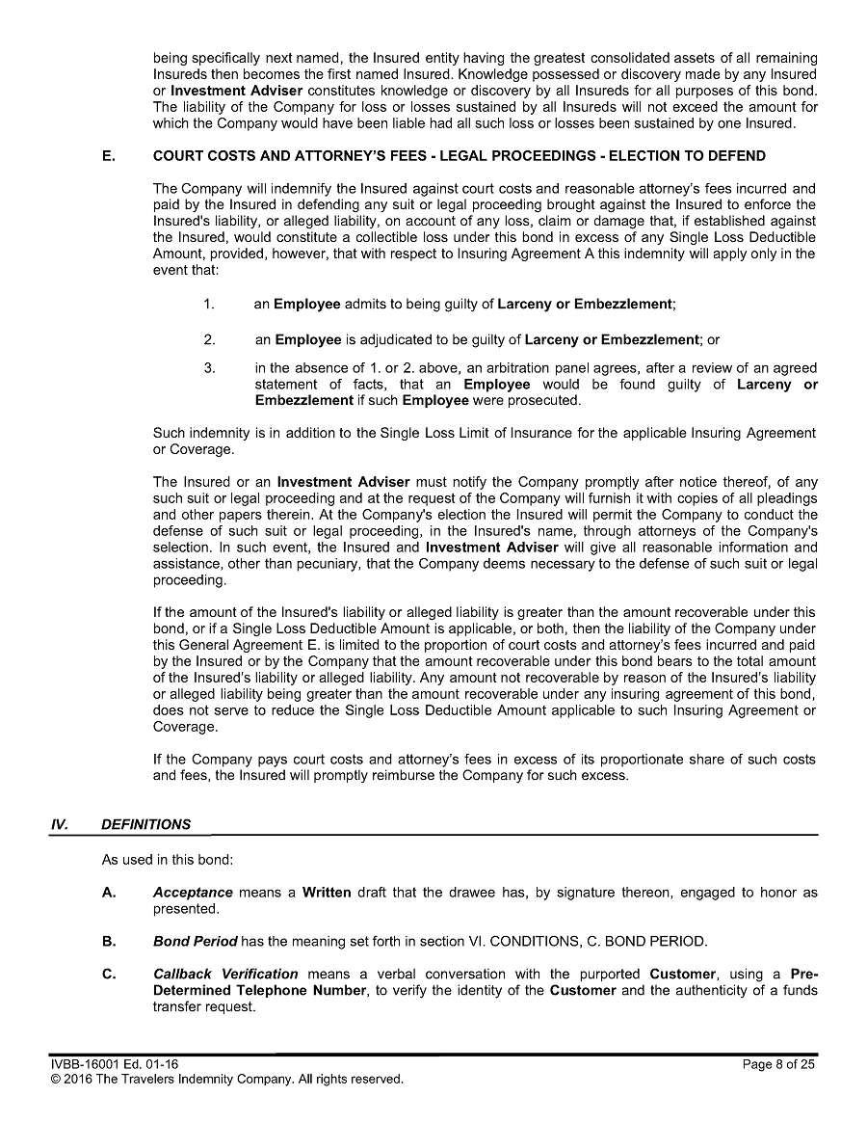

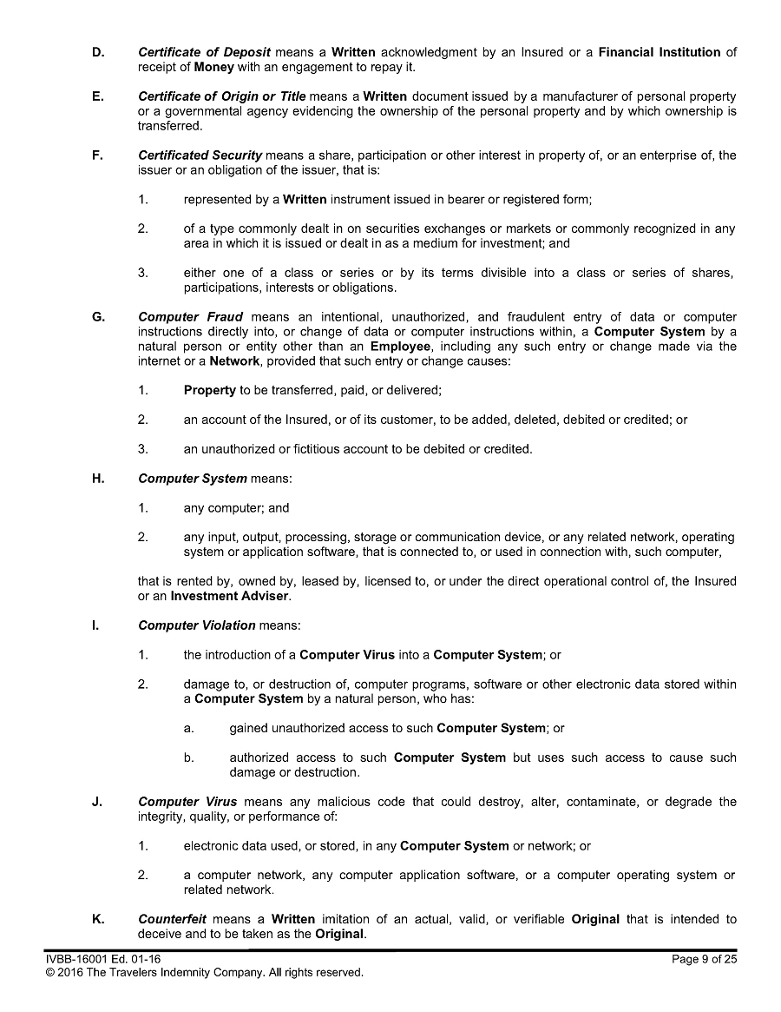

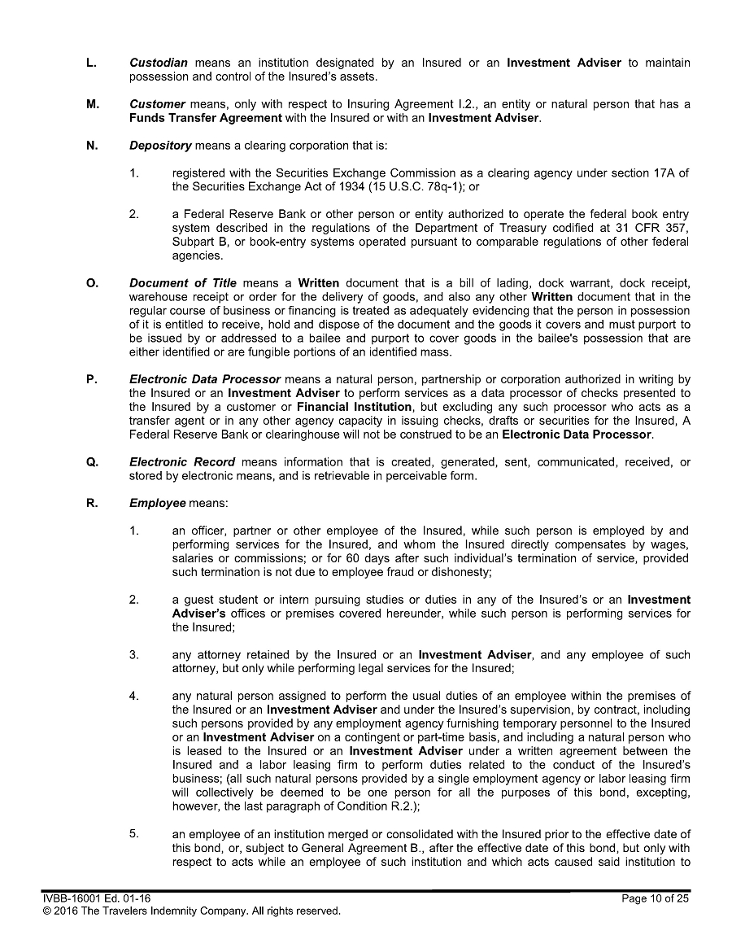

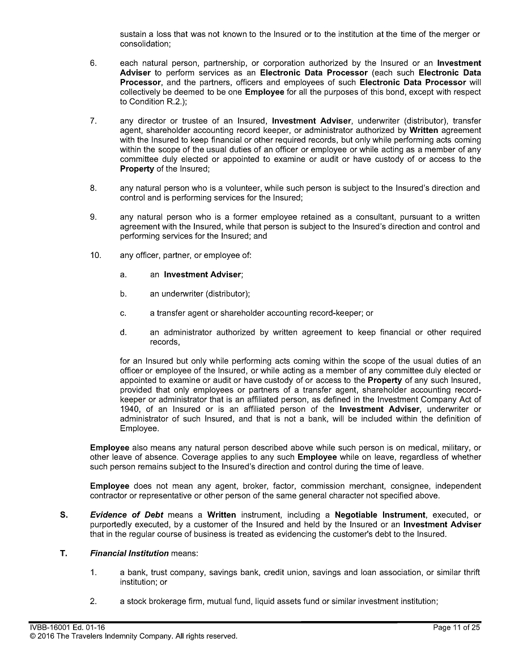

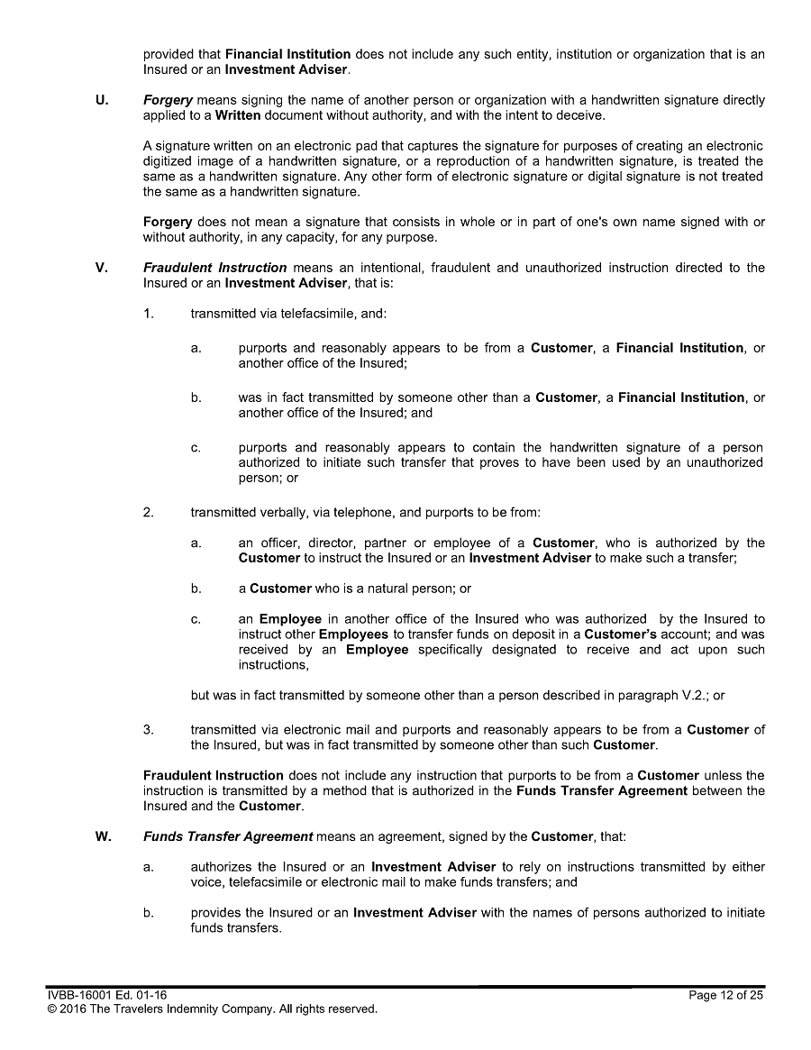

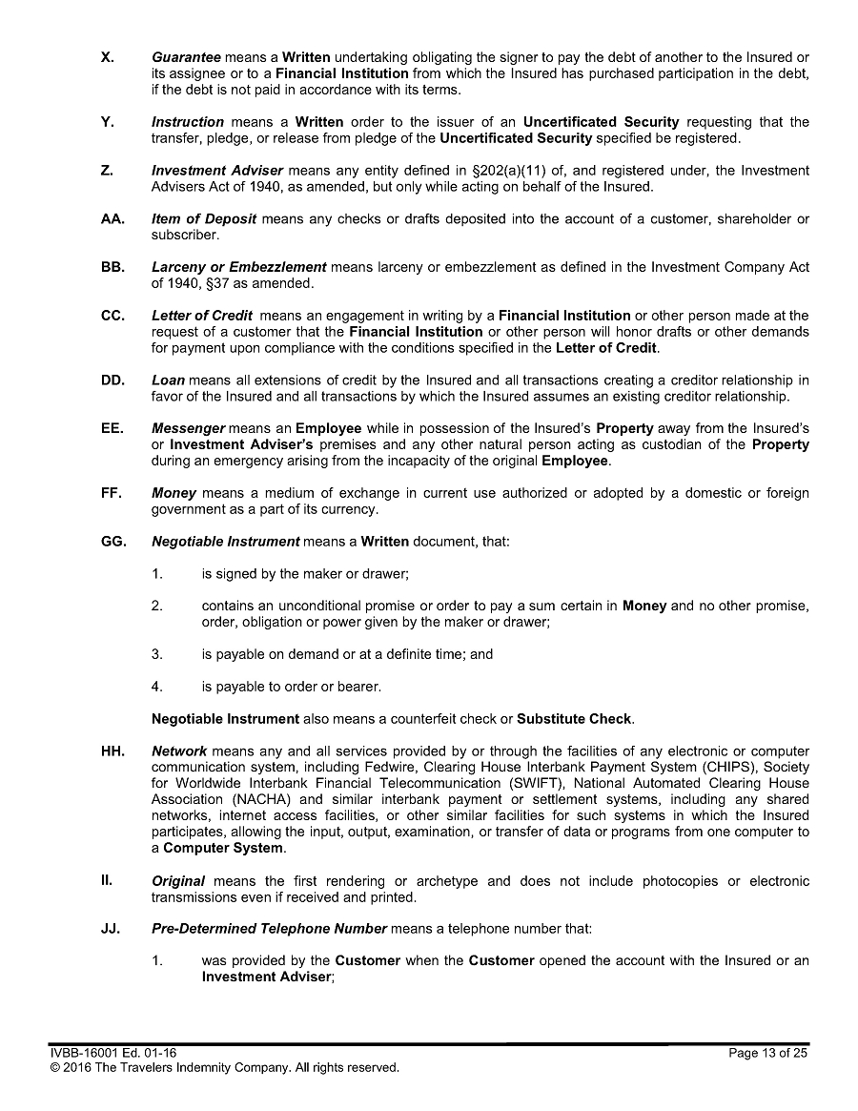

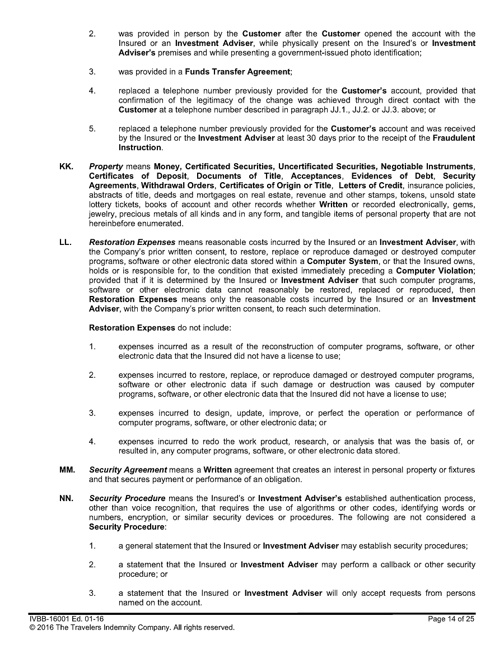

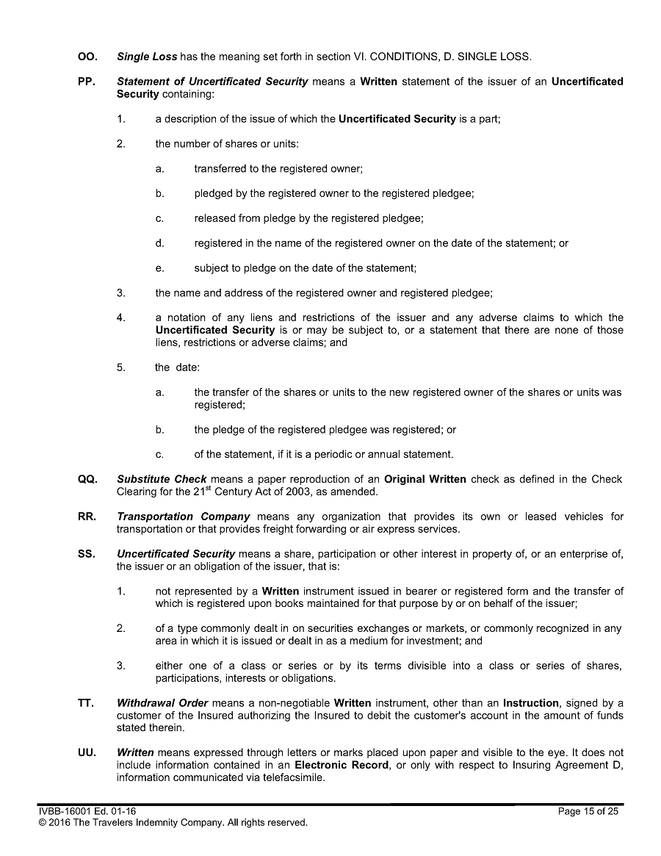

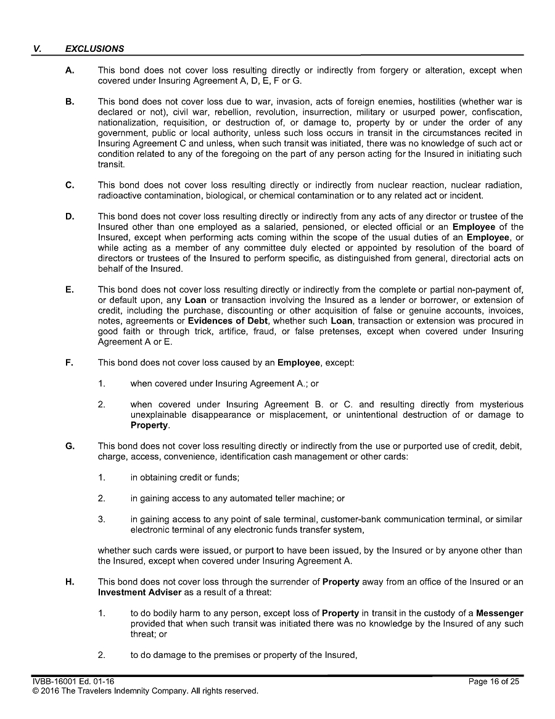

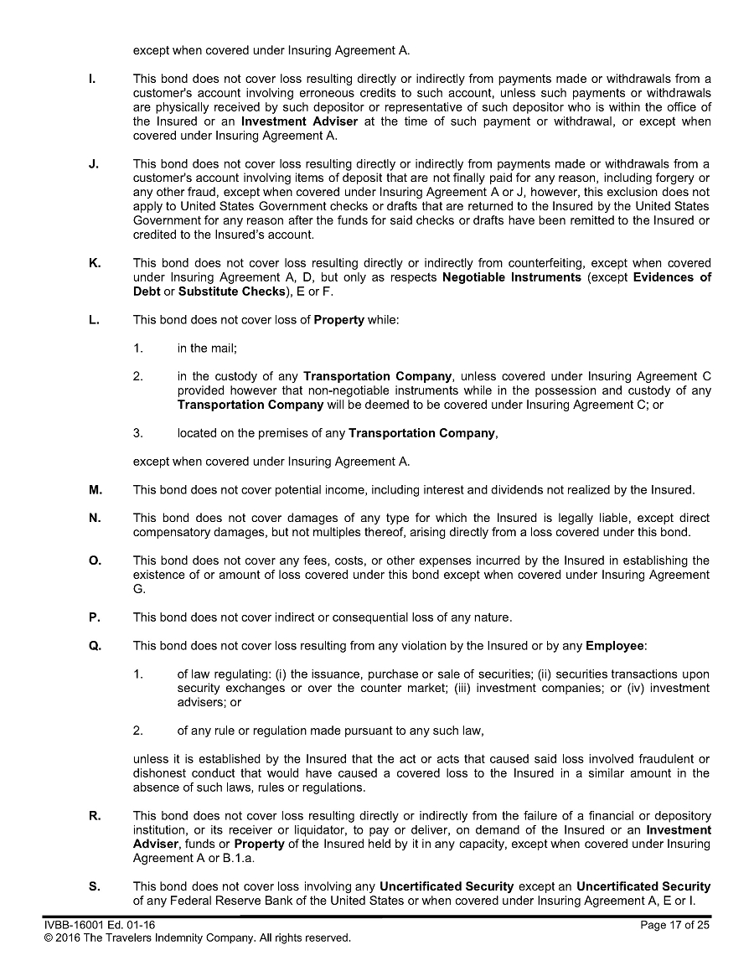

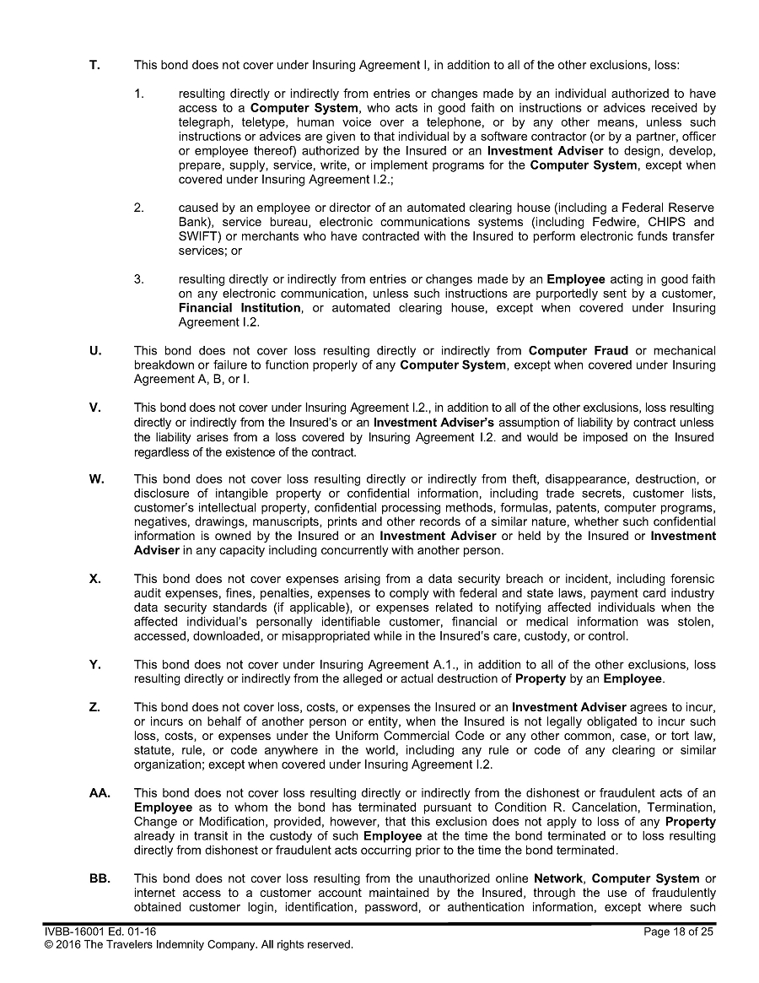

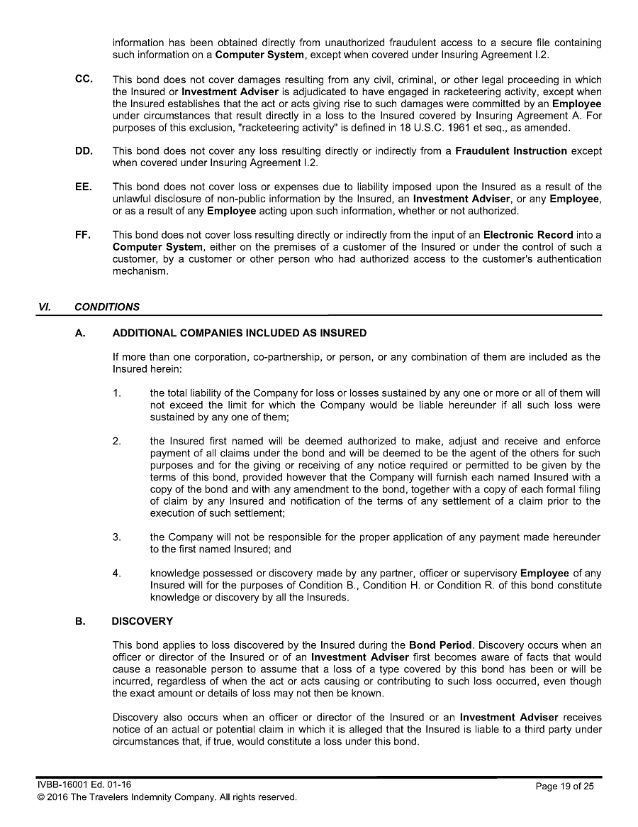

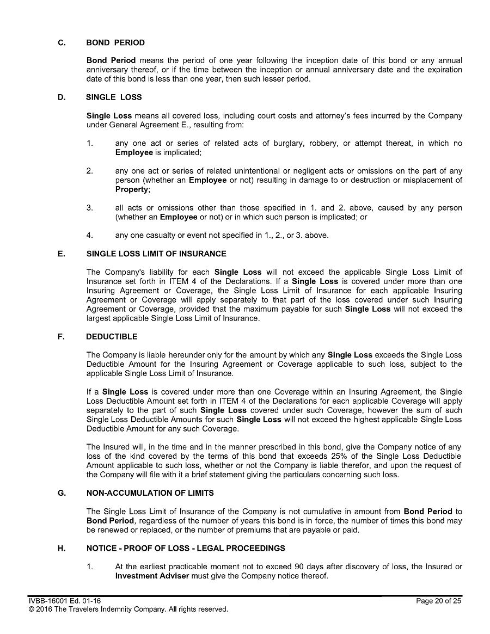

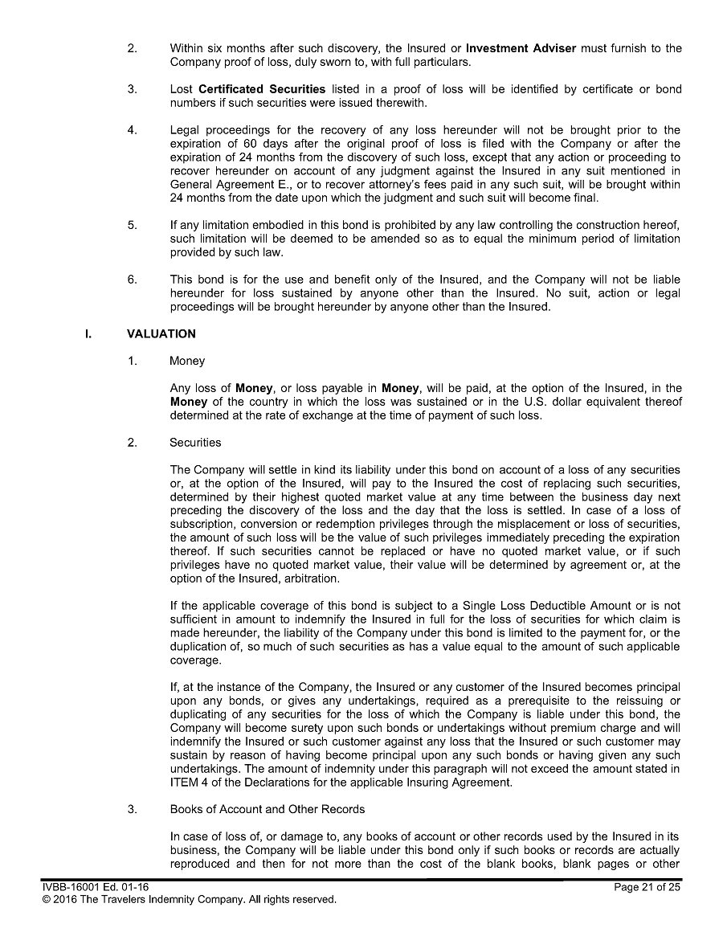

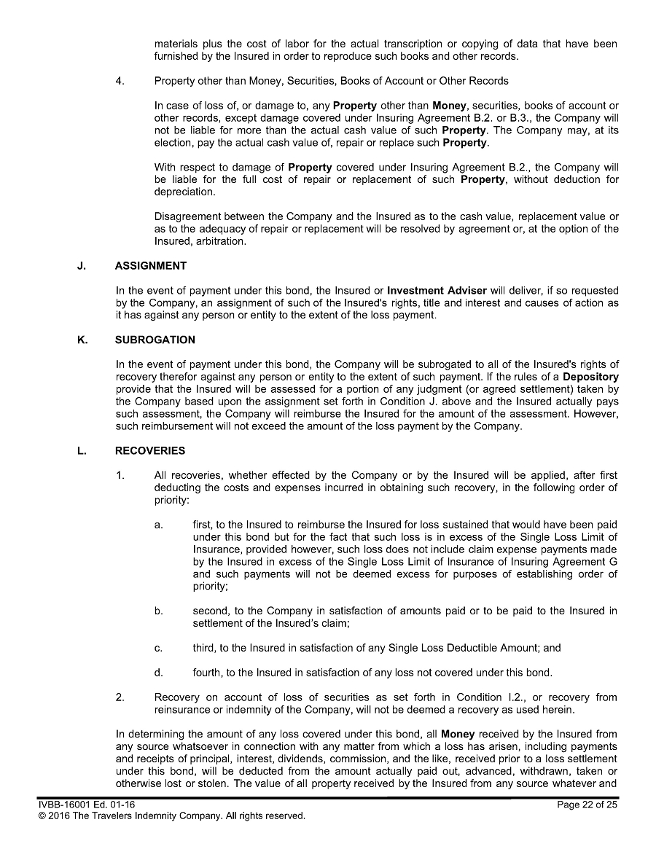

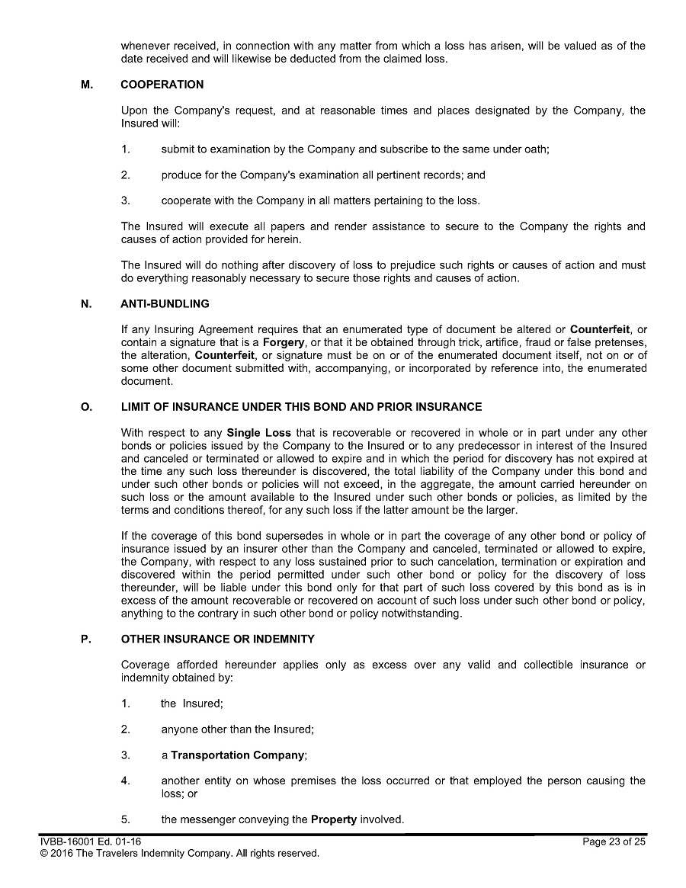

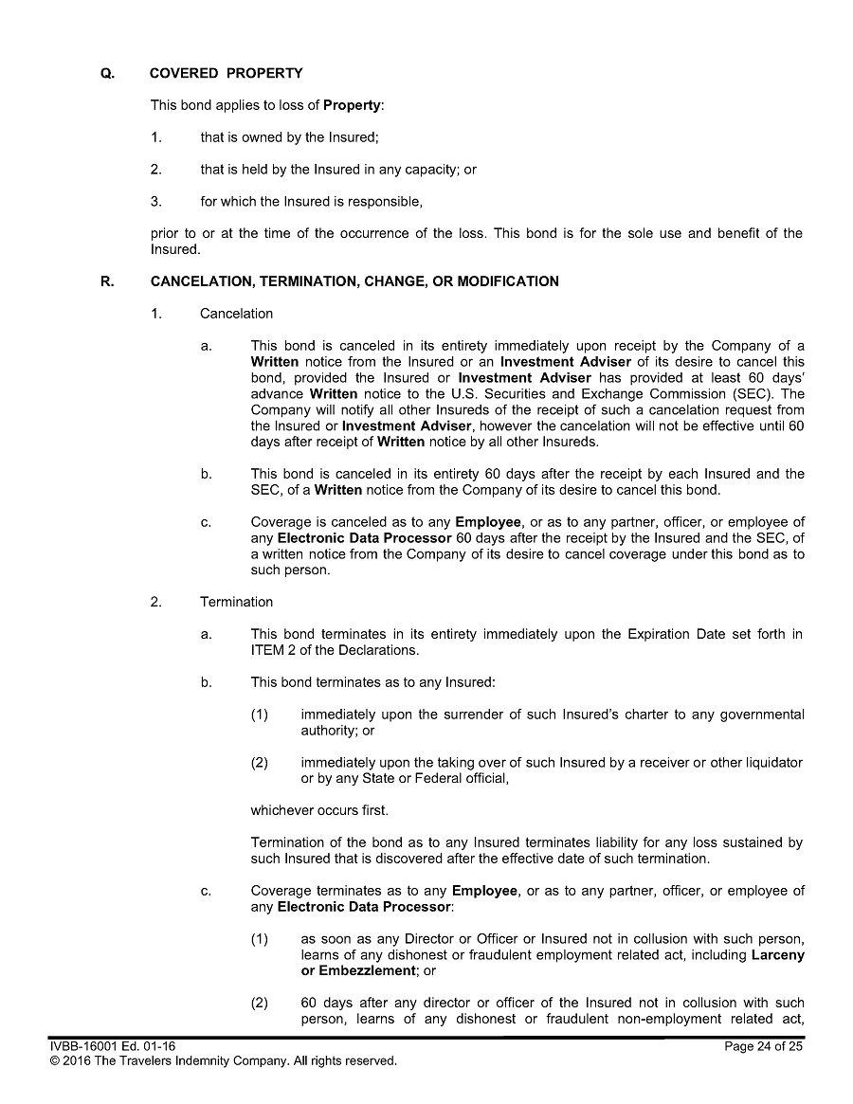

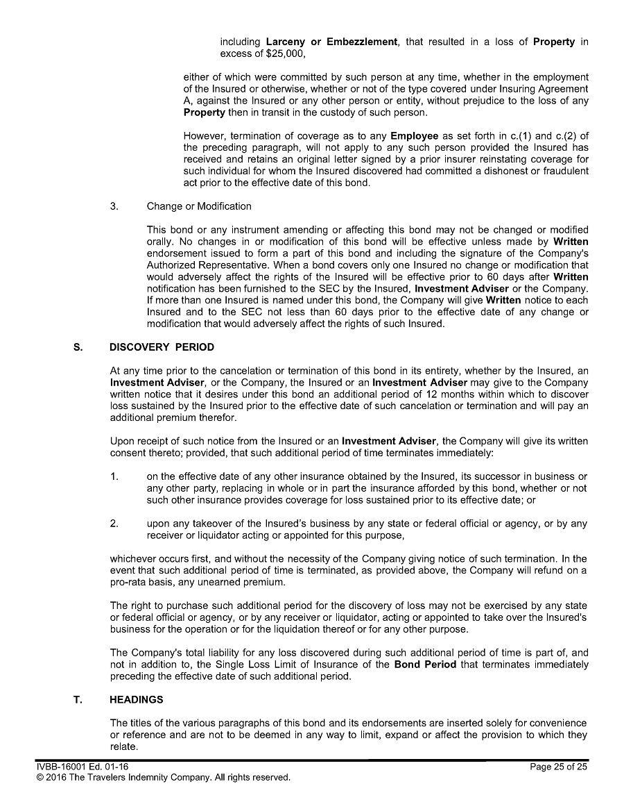

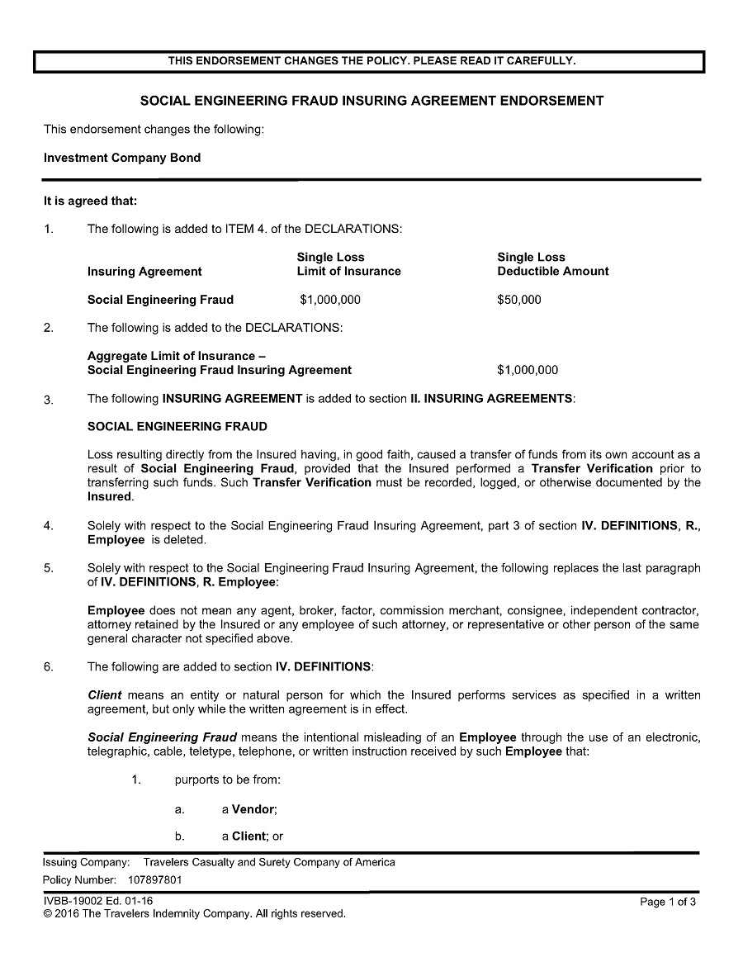

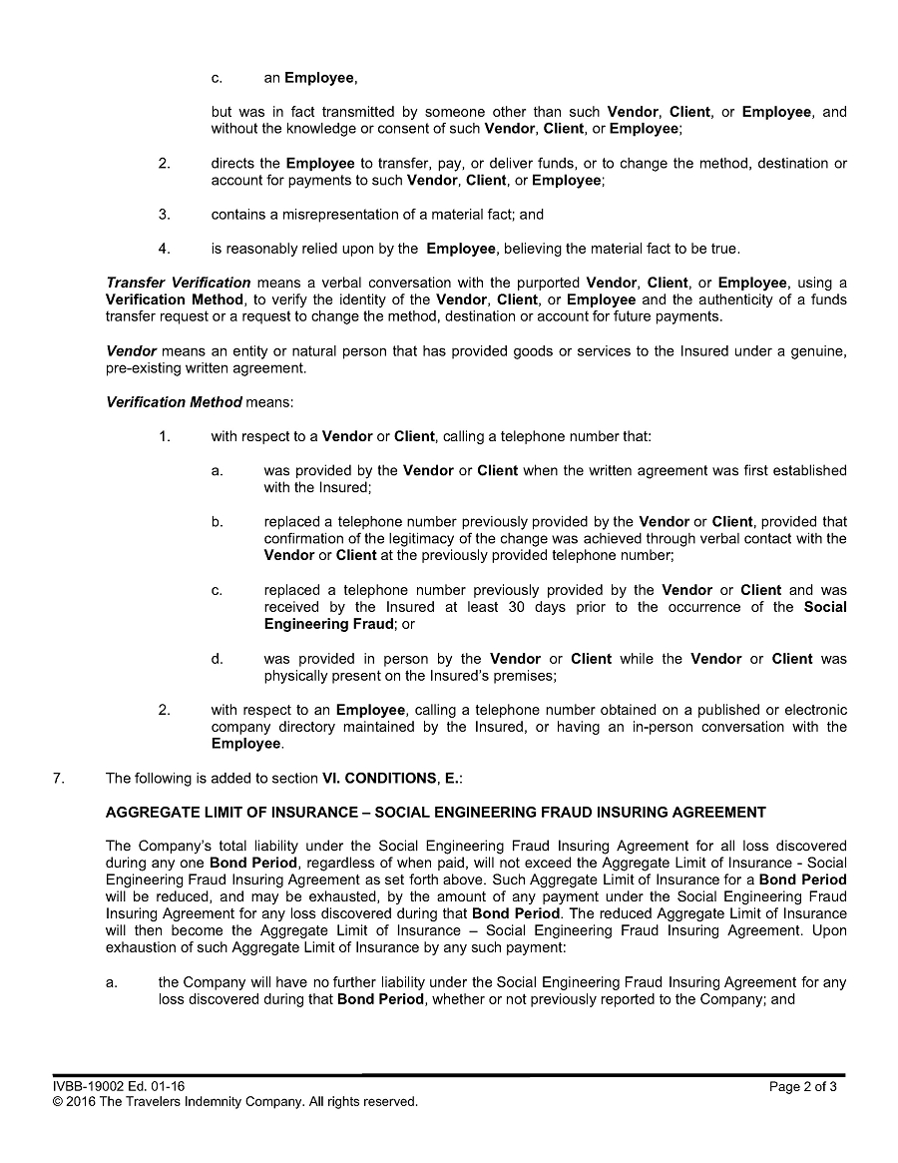

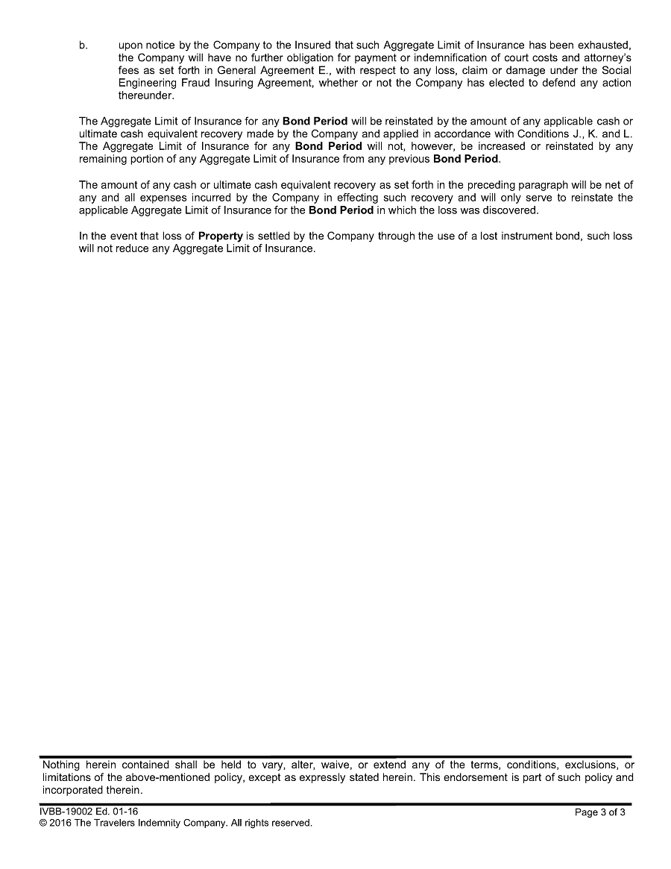

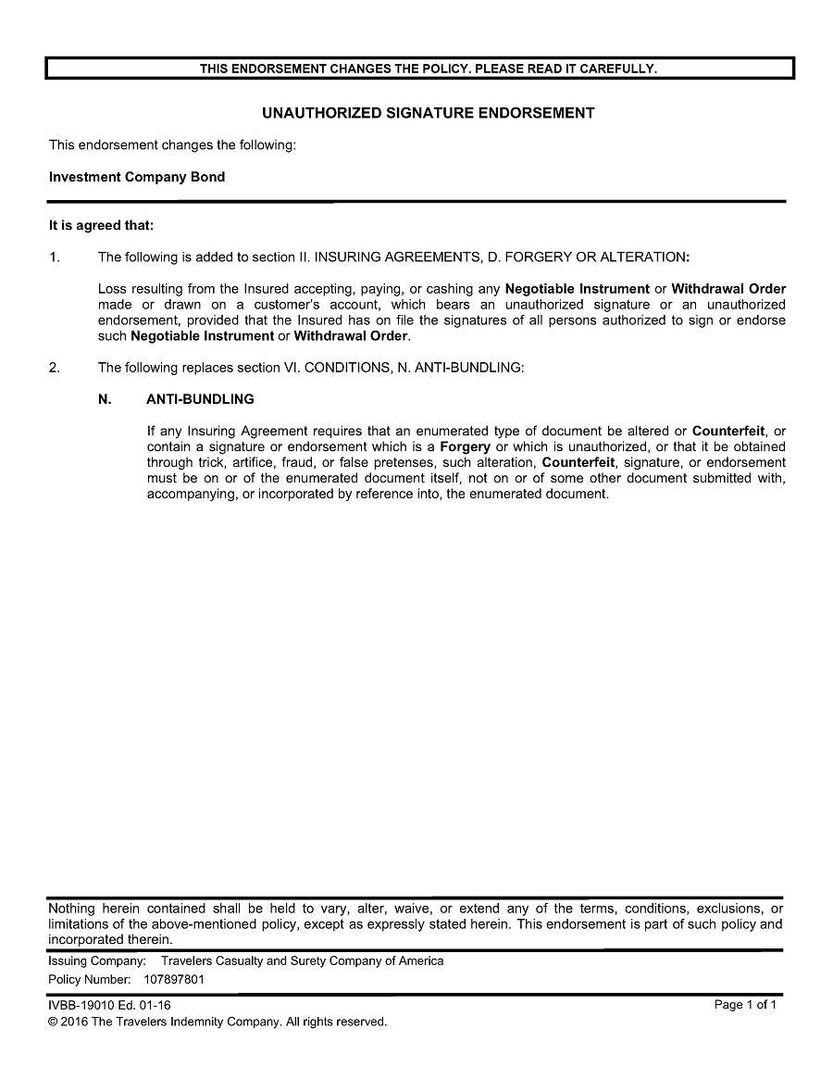

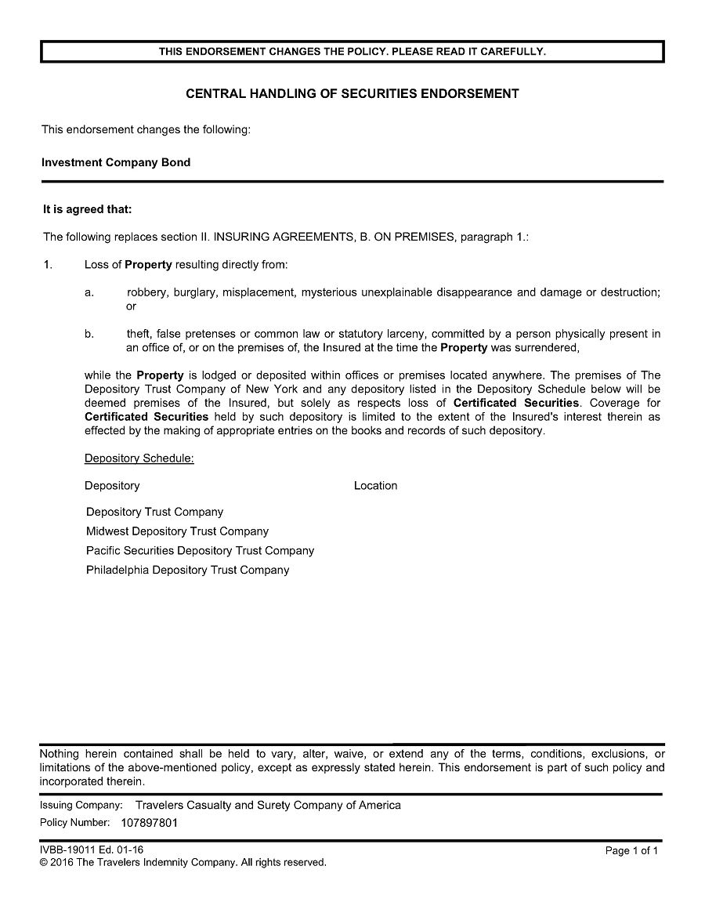

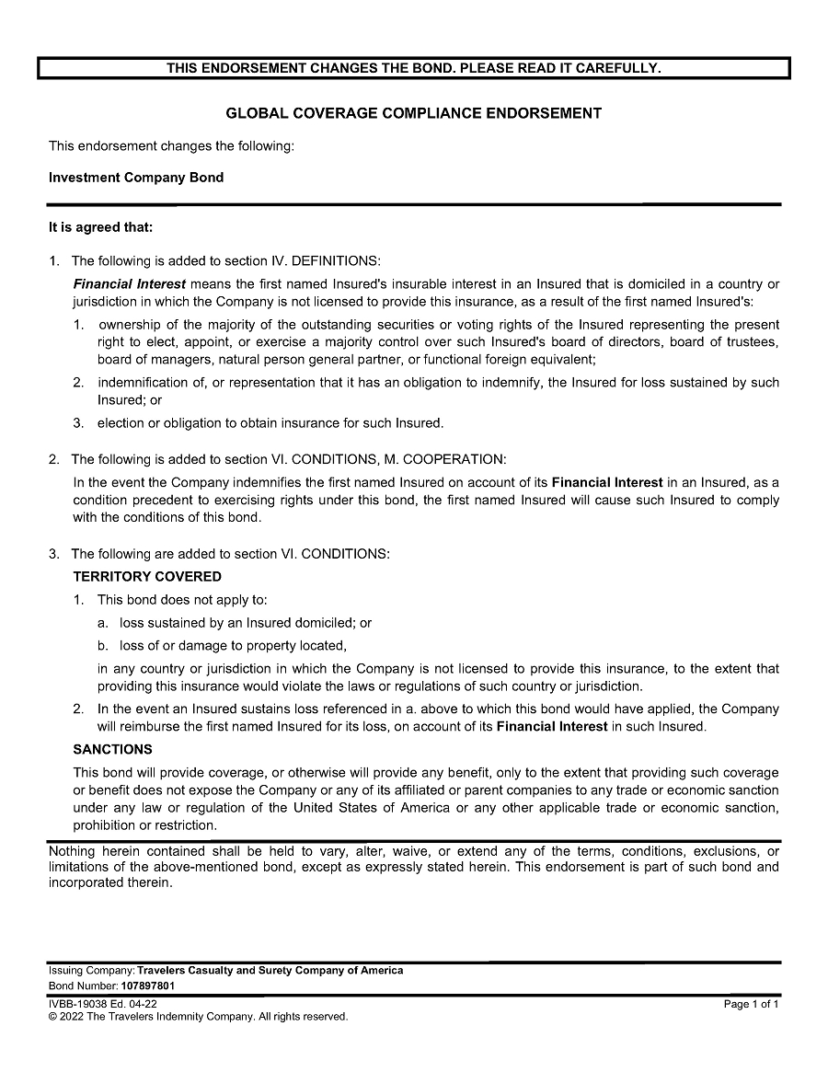

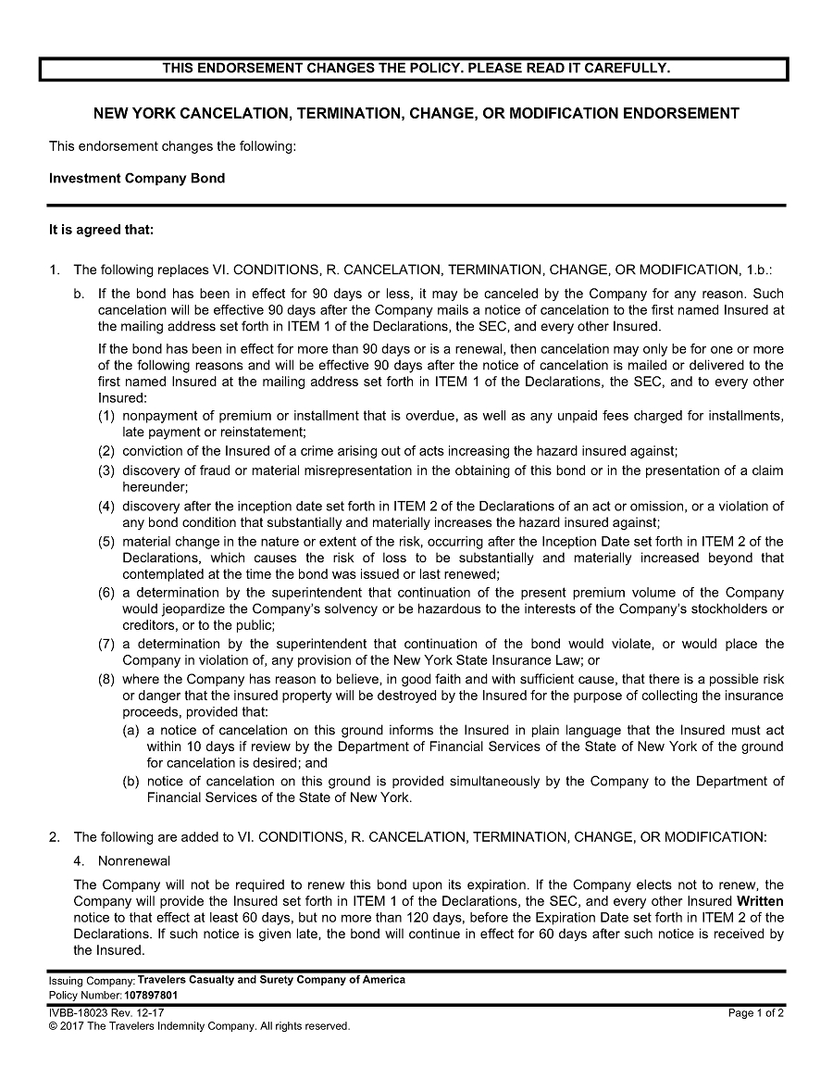

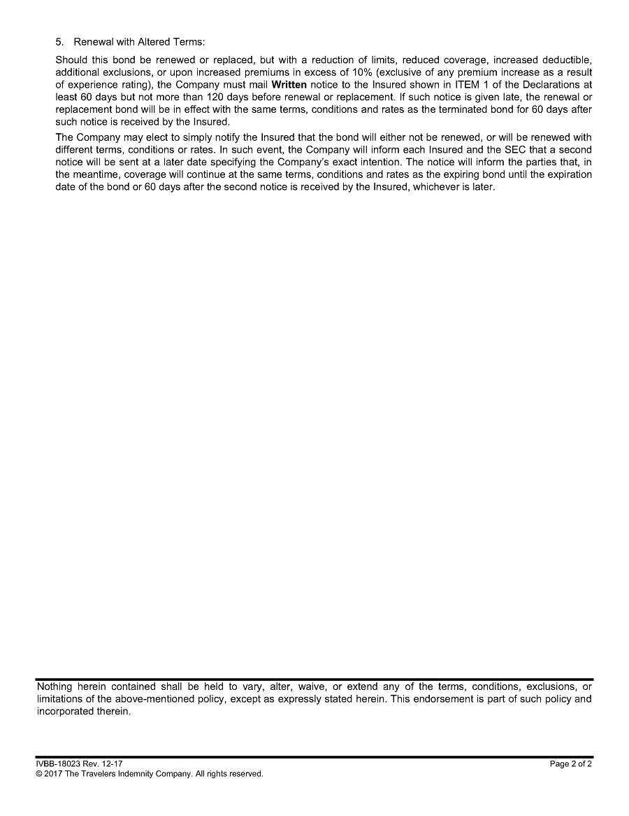

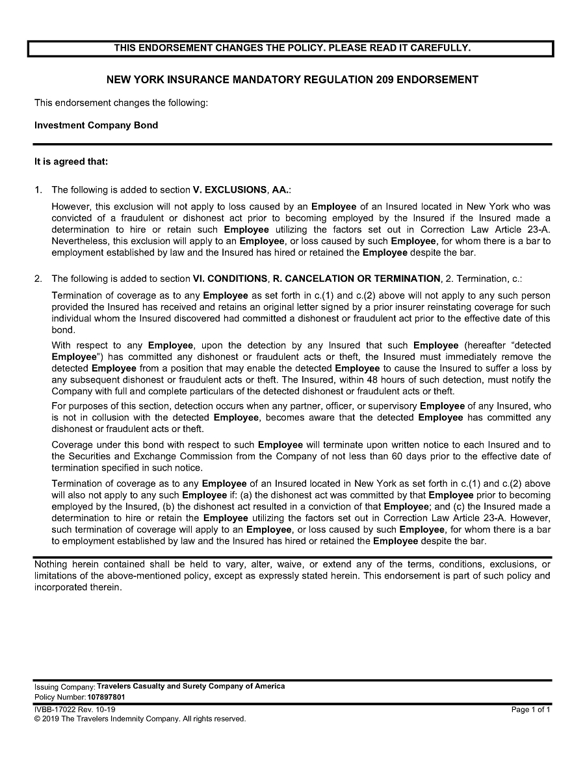

CERTIFICATE OF SECRETARY

The undersigned, Allison Green, Chief Financial Officer, Treasurer and Corporate Secretary of Neostellar Capital Corp., a Maryland corporation (the “Company”), does hereby certify that:

 | 1. | This certificate is being delivered to the Securities and Exchange Commission (the “SEC”) in connection with the filing of the Company’s fidelity bond (the “Bond”) pursuant to Rule 17g-1 under the Investment Company Act of 1940, as amended (the “1940 Act”), and the SEC is entitled to rely on this certificate for purposes of the filing.
 | 2. | The undersigned is the duly elected, qualified and acting Chief Financial Officer, Treasurer and Corporate Secretary of the Company, and has custody of the corporate records of the Company and is a proper officer to make this certification.
 | 3. | Attached hereto as Exhibit A is a copy of the resolutions approved by the board of directors of the Company, including a majority of the directors who are not “interested persons” of the Company within the meaning of Section 2(a)(19) of the 1940 Act, approving the amount, type, form and coverage of the Bond.
 | 4. | Premiums have been paid for the period from August 29, 2026 to August 29, 2027.

IN WITNESS WHEREOF, the undersigned has caused this certificate to be executed this 2nd day of September, 2026.

/s/ Allison Green
Allison Green
Chief Financial Officer, Treasurer and Corporate Secretary of the Company

Exhibit A

Resolutions of the Board of Directors
of Neostellar Capital Corp.

Approved on July 30, 2026

Review and Approval of Fidelity Bond

WHEREAS, Section 17(g) of the 1940 Act and Rule 17g-1(a) thereunder require a business development company, such as the Company, to provide and maintain a bond which shall be issued by a reputable fidelity insurance company, authorized to do business in the place where the bond is issued, to protect the Company against larceny and embezzlement, covering each officer and employee of the Company who may singly, or jointly with others, have access to the securities or funds of the Company, either directly or through authority to draw upon such funds or to direct generally the disposition of such securities, unless the officer or employee has such access solely through his position as an officer or employee of a bank (each, a “Covered Person”); and

WHEREAS, Rule 17g-1 specifies that the bond may be in the form of (i) an individual bond for each Covered Person, or a schedule or blanket bond covering such persons, (ii) a blanket bond which names the Company as the only insured, or (iii) a bond which names the Company and one or more other parties as insureds, as permitted by Rule 17g-1; and

WHEREAS, Rule 17g-1 requires that a majority of all Independent Directors of the Company approve periodically (but not less than once every 12 months) the reasonableness of the form and amount of the bond, with due consideration to the value of the aggregate assets of the Company to which any Covered Person may have access, the type and terms of the arrangements made for the custody and safekeeping of such assets, and the nature of securities and other investments to be held by the Company, and pursuant to factors contained in Rule 17g-1, as detailed in the Board Materials; and

WHEREAS, under Rule 17g-1, the Company is required to make certain filings with the Securities and Exchange Commission (the “SEC”) and give certain notices to each member of the Board in connection with the bond, and designate an officer who shall make such filings and give such notices; and

WHEREAS, the Board, including all of the Independent Directors, has received and reviewed a copy of the current fidelity bond issued by Travelers Casualty and Surety Company of America, a reputable fidelity insurance company, in an amount equal to $1,000,000 (the “Current Fidelity Bond”), which provides fidelity bond coverage for the Company, as detailed in the Board Materials; and

WHEREAS, the Board, including all of the Independent Directors, previously approved the Current Fidelity Bond, including the premium for such Current Fidelity Bond; and

WHEREAS, the Authorized Officers are negotiating a new fidelity bond to be issued by Travelers Casualty and Surety Company of America upon expiration of the Current Fidelity Bond with such terms as any Authorized Officer shall approve, such approval to be conclusively evidenced by the execution thereof, and to make payments and incur such expenses as any Authorized Officer shall approve in connection therewith; provided, that such new fidelity bond is issued on substantially the same terms and conditions as the Current Fidelity Bond, including an aggregate bond amount of $1,000,000 to cover the officers and employees of the Company and to insure the Company against loss from fraudulent or dishonest acts, including larceny and embezzlement (such new fidelity bond meeting this requirement, the “New Fidelity Bond”); and

WHEREAS, the Board, including all of the Independent Directors, has considered the expected aggregate value of the securities and funds of the Company to which the Company’s officers and employees may have access (either directly or through authority to draw upon such funds or to direct generally the disposition of such securities), the type and terms of the arrangements made for the custody of such securities and funds, the nature of securities and other investments to be held by the Company, the accounting procedures and controls of the Company, the nature and method of conducting the operations of the Company, the requirements of Section 17(g) of the 1940 Act and Rule 17g-1 thereunder, and all other factors deemed relevant by the Board, including such Independent Directors; and

WHEREAS, the Board has received and reviewed the proposed terms of the New Fidelity Bond and believes it to be in the best interests of the Company to approve such fidelity bond.

NOW, THEREFORE, BE IT RESOLVED, that, having considered the expected aggregate value of the securities and funds of the Company to which officers or employees of the Company may have access (either directly or through authority to draw upon such funds or to direct generally the disposition of such securities), the type and terms of the arrangements made for the custody of such securities and funds, the nature of securities and other investments to be held by the Company, the accounting procedures and controls of the Company, the nature and method of conducting the operations of the Company and the requirements of Section 17(g) of the 1940 Act and Rule 17g-1 thereunder, the Board, including all of the Independent Directors, hereby authorizes the Authorized Officers, and each of them individually, to negotiate, execute and deliver such documents or agreements as may be necessary to cause the New Fidelity Bond to be issued upon expiration of the Current Fidelity Bond with such terms and premium as any Authorized Officer shall approve, such approval to be conclusively evidenced by the execution thereof, and to make payments and incur such expenses as any Authorized Officer shall approve in connection therewith; provided, that such New Fidelity Bond is issued on substantially the same terms and conditions as the Current Fidelity Bond, including an aggregate bond amount of $1,000,000 to cover the officers and employees of the Company and to insure the Company against loss from fraudulent or dishonest acts, including larceny and embezzlement; and

FURTHER RESOLVED, that the Board, including all of the Independent Directors, hereby finds that the form and amount of the New Fidelity Bond are reasonable, and the terms and conditions of the New Fidelity Bond are hereby approved in all respects by the Board and all of the Independent Directors; provided, that such New Fidelity Bond is issued in conformity with the foregoing resolution; and

FURTHER RESOLVED, that the Authorized Officers be, and each of them hereby is, authorized, empowered, and directed (i) to negotiate, execute, and deliver such documents or agreements as may be necessary to cause the New Fidelity Bond to be issued, (ii) to take all appropriate actions, with the advice of legal counsel to the Company, to provide and maintain the New Fidelity Bond on behalf of the Company, and (iii) to do and perform all acts and things in connection with the foregoing, and to cause the Company to perform its obligations thereunder, including, but not limited to, paying of any premiums; and

FURTHER RESOLVED, that the Chief Compliance Officer of the Company be, and hereby is, designated as the party responsible for making the necessary filings and giving the notices with respect to such bond required by paragraph (g) of Rule 17g-1 under the 1940 Act; and

FURTHER RESOLVED, that the Authorized Officers be, and each of them hereby is, authorized, empowered, and directed to file a copy of the New Fidelity Bond and any other related document or instrument with the SEC; and

FURTHER RESOLVED, that the Authorized Officers be, and each of them hereby is, authorized, empowered, and directed, in the name and on behalf of the Company, to make or cause to be made, and to execute and deliver, all such additional agreements, documents, instruments, and certifications and to take all such steps, and to make all such payments, fees and remittances, as any one or more of such officers may at any time or times deem necessary or desirable in order to effectuate the purpose and intent of the foregoing resolutions; and

FURTHER RESOLVED, that any and all actions previously taken by the Company or any of its directors or Authorized Officers in connection with the documents and actions contemplated by the foregoing resolutions be, and they hereby are, ratified, confirmed, approved, and adopted in all respects as and for the acts and deeds of the Company; and

FURTHER RESOLVED, that for purposes of the foregoing resolutions, the Authorized Officers of the Company shall be the President, the Chief Executive Officer, the Chief Financial Officer, the Chief Compliance Officer, the Treasurer and the Corporate Secretary of the Company (each, an “Authorized Officer,” and collectively, the “Authorized Officers”).

